## Assessment Center I | 4 questions

1. Explain from your perspective what to pay attention when creating tableau dashboards?
2. Give feedback on the layout/ KPIs of the dashboard - name 3 positive and 3 negative aspects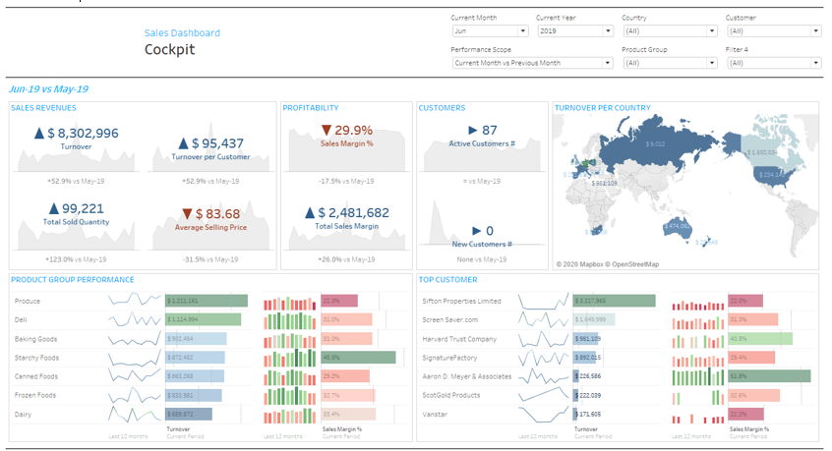
3. How can you connect Tableau with external systems What do you have to pay attention to?
4. How to improve data quality How can you improve the performance of a workbook? What are the possibilities?

Answer

1. There are following thing that I keep in my mind like

* Visualization is providing information to even layman, so we must make our dashboard in that direction.
* Avoid using too many sheets.
* Proper heading and subheading.
* Uses of filter and legends wherever there is necessary.

1. Positive

* Heading is properly given
* Legends and filter are properly used
* Insightful dashboard

Negative

* Closed packed sheet in dashboard
* Formatting of the sheets
* Too much information in one sheet.

1. Data security policy must not be violated and there is authorization to use data source
2. I always use tableau prep to improve the data before going to the tableau desktop

Tableau prep is used to preprocess and clean the raw data and perform some basic operation as per business.

In Tableau desktop we keep in mind that

* Performance of data analyzing
* Information provided to the end users